**Project report**



**TEAM MEMBERS: SUBMITTED TO:  
Ahmed Affan Raza MS. KHADIJA TUL QUBRA  
Syed Umar Hasan  
Hasnain Raza  
BCS – 1E**

Introduction:

We created the digital library application that enables users to securely create, manage, and store their important records. This specific diary project includes features such as user authentication (using usernames and passwords), ensuring that each user's data is private and only accessible to them.

Application

It includes user authentication, creating new data entries, viewing and editing existing data entries, searching entries and deleting them. Searching can include searching by time, number and date. The data for each user will be stored separately.

Why did you choose it

Firstly, Diary application is easier and useful application for storing useful thoughts tasks of daily life. Secondly, we can also learn skills related to data privacy and security to avoid breaches. Most importantly, this project can also help with our project in functions, data structures recursion and manipulation of string.

Design & Implementation:

Write Pseudocode and Draw your flowcharts.

Pseudocode:

1. **signup ()**: Allows a new user to create an account by saving a username and password to a file.
2. **login ()**: Authenticates an existing user by checking entered credentials against the stored ones in users.txt.
3. **menu ()**: Displays main menu options (e.g., create new notes, view existing notes, or exit).
4. **current User**: Global variable that stores the username of the currently logged-in user.
5. **Input validation**: get_valid_input ()
6. **Exit** : This ends the program

If the user chooses:

1. **Signup**: Call the Signup () function.
2. **Login**: Call the login () function.
3. **Exit** ; Ends the program
4. **Else**: Display an invalid choice message and exit.

**Signup ()**

**Prompt the user to enter a new username and password.**

**Open the users.txt file in append mode.**

**Write the username and password into the file (separated by space or newline).**

**Close the file.**

**Display a "Registration successful" message.**

**Return to the main menu.**

**Login ()**

1. **Prompt the user to enter a username:**

**Call get_valid_input () to validate the username.**

1. **Prompt the user to enter a password:**

**Call get_valid_input() to validate the password.**

1. **Loop through each pair of saved username and password in the file:**
   * **Compare the input username and password with the saved username and password.**
   * **If a match is found:**
     + **Save the username in current User.**
     + **Set an authenticated flag to 1.**
     + **Break the loop.**
2. **Close the file.**
3. **If authenticated == 1:**
   * **Clear the screen.**
   * **Display a "Login Successful" message with the username.**
4. **If authenticated == 0, display "Invalid username or password."**

**Menu ()**

This function displays the main menu

1. Add a new note by calling addNewnote () to create a new note.
2. View existing notes by calling existing note () to view existing notes based on time ,date and note number .
3. Delete existing notes by calling deletenote()
4. Editing notes by calling editnote ()
5. Exit

This menu() function uses switch cases statement to decide which option or case has been selected.

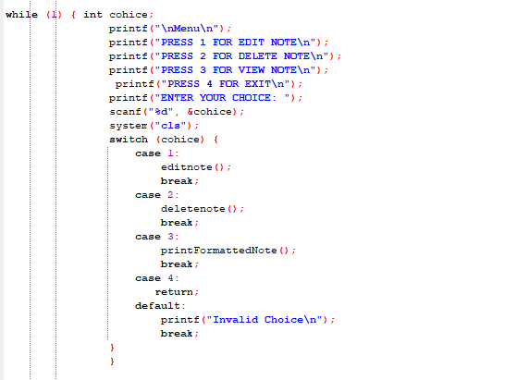

Flowchart:

Display The menu

1.Login 2. Signup 3. Exit

1.Add a note

2. View existing note

3. Delete existing note

4.Exit

Signup

Login

Get User input

Successful Login message and direct main menu

Validate Credentials

Enter Credentials

Main Menu

Redirect to menu

Enter Username and password

Save to File

Open users.txt

Open user.txt

Results:

The program consists of 6 main modules

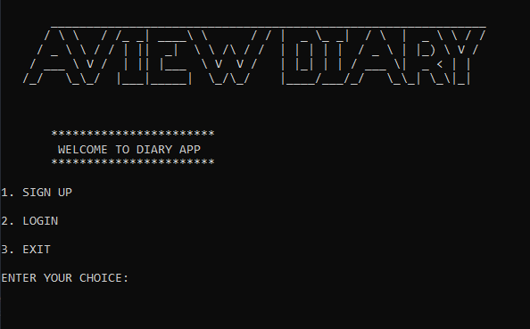

Sign up Login Menu

Adding a new note

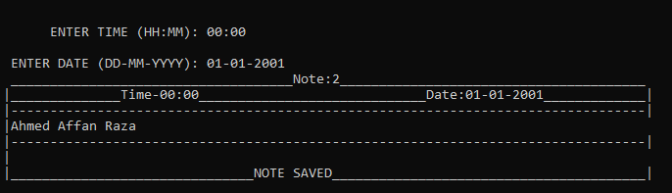

Viewing all existing notes

Deleting existing notes

